**Credential Issuance flow**

1. Provide ID for which credential has to be issued.

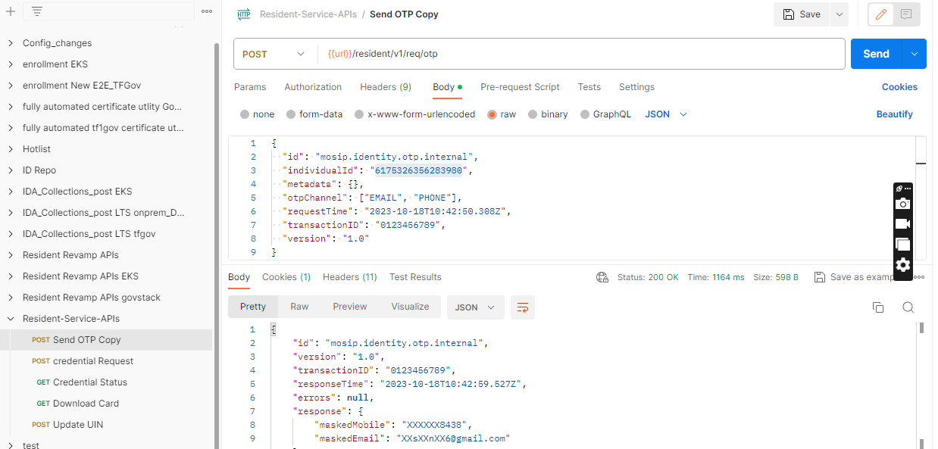

Notification



1. 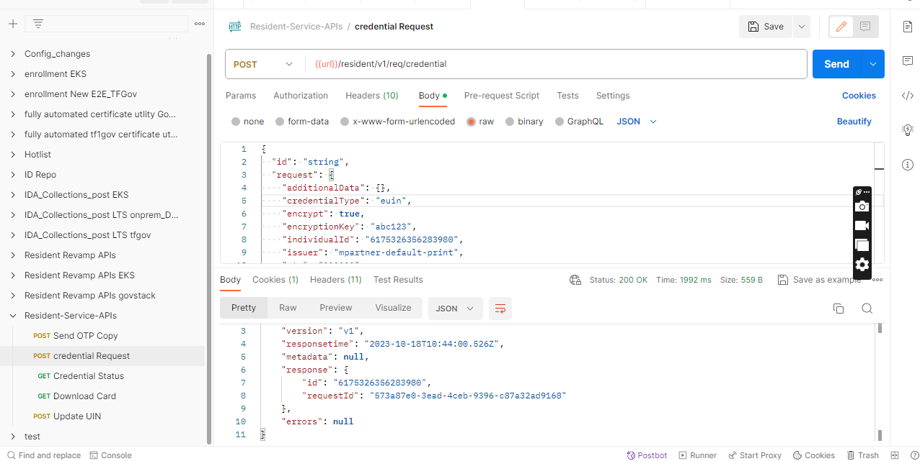Retrieve the exact credential information instead of regenerating the credential when it is lost or stolen.

Notification

1. The status of Credential.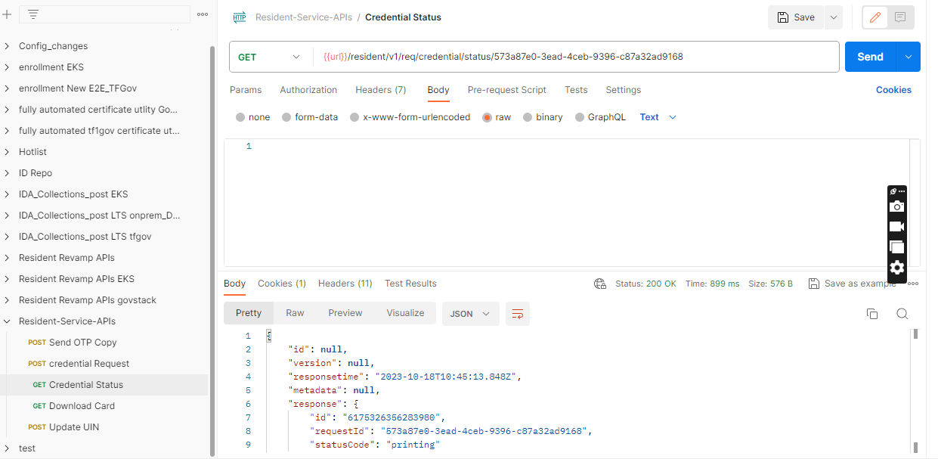

Notification

1. 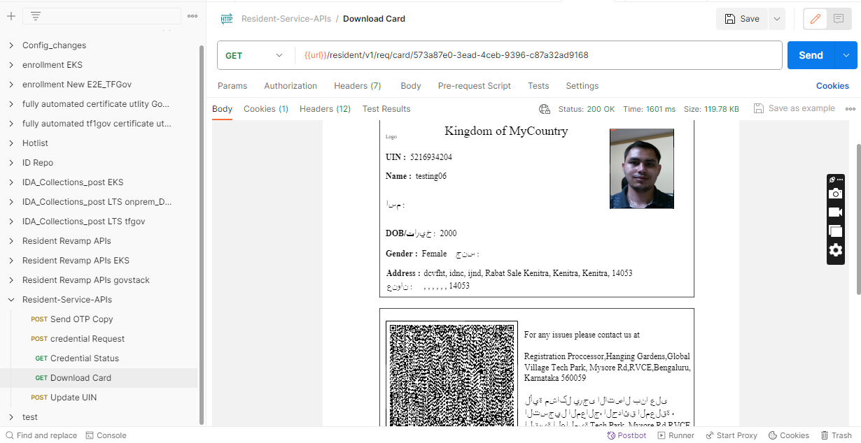Download card for credential issuance.